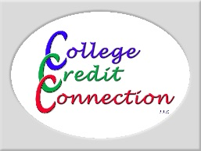

Come earn graduate-level semester units with me!

Why take a CCC course together?
- Enjoy the flexibility of an online course with the benefit of shared learning
- Collaborate on lesson plans and assessments
- Share ideas and reflect on our learning together
- Include your group collaboration time in your required Journal Log hours!
- Graduate units can be used for salary step advancement and recertification

College Credit Connection offers K-12 and Community College educators the opportunity to earn graduate-level semester units through Vanguard University of Southern California, which is fully accredited by the Western Association of Schools and Colleges (WASC).

Interested?
- Contact: ___________________
Email:___________________
Text:____________________
- Course Name:
____________________________
- Tentative meeting date(s) and location:
_____________________________
_____________

ENROLL ONLINE AT
WWW.COLLEGECREDITCONNECTION.COM

Affordable • Flexible Scheduling • Self-paced • Quality Curriculum • Relevant and Applicable

